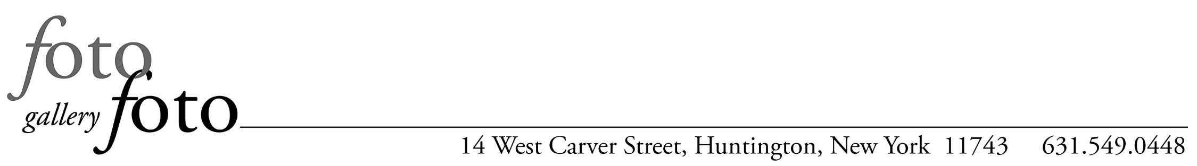
Mailing Address: P.O. Box 511, Huntington, NY 11743

MEMBERSHIP APPLICATION

fotofoto gallery is a photographers’ collective dedicated to the artistic development of photographers, both its members and the greater photographic community. The gallery sponsors an extensive calendar of exhibitions, workshops, salons, competitions and special events. fotofoto gallery, formed in 2003, is a 501(c)(3) non-profit.

MEMBERSHIP LEVELS
- Full Artist Member: Entitled to 1 solo show per calendar year in addition to all other gallery benefits.
- Portfolio Artist Member: Members enjoy the same benefits as full members except they may only exhibit in our group shows. (No solo shows.)

BENEFITS OF MEMBERSHIP
- Exhibition Opportunities - members have regular opportunities for solo exhibitions and may submit work for all group shows that include gallery artists.
- Workshops - members receive discounts for gallery sponsored workshops and may create their own workshops to offer to the members or the community at large.
- Networking – work with other artists to explore ideas.
- Curating – group shows of outside artists provide members the opportunity to curate and hang exhibitions.
- Salons – the gallery runs regular salons where members and other artists review ongoing projects.

RESPONSIBILITIES OF MEMBERSHIP
- Demonstrate continuing artistic and technical competence as a photographer.
- Attend monthly meetings and receptions and participate in other gallery events.
- Gallery Sit 2 shifts per month for group and competition exhibitions, more for your solo exhibition.
- Serve on committees.
- Help install group exhibitions and help maintain the gallery.

DUES
- Full Artist Members pay $100 per month.
- Portfolio Artist Members pay $50 per month.
- Members are responsible for all costs associated with their exhibitions. No additional fee for a show.

HOW TO BECOME A MEMBER
- The gallery reviews the portfolios of prospective members on an ongoing basis.
- To present a portfolio, please contact the gallery at info@fotofotogallery.org
- Put "PORTFOLIO SUBMISSION" in caps in the subject area of the email.

SUBMITTING A PORTFOLIO
- Artist Membership at both levels is limited to individuals 18 or older.
- There is no charge for submitting a portfolio for review.
- Please submit 12 – 15 images from an ongoing project or projects.
- All portfolios must be photography-based.
- Work must be matted or presented as it would be prepared for exhibition – do not include frames.
- Only original work may be presented for a portfolio review
- Please include social media links (website, Facebook, Instagram, YouTube Channel) if available.
- Attach a Bio/Artist Statement.

Gallery Hours: Thursday 12:30-4pm; Friday - Saturday 11:30am-6pm' and by appointment.
www.fotofotogallery.org fotofoto gallery is a 501(c)(3) organization

Mailing Address: P.O. Box 511, Huntington, NY 11743

Please include this form with your portfolio.

I am submitting works for review for:
- Full Artist Membership: Yes ___ No ___
- Portfolio Artist Membership: Yes ___ No ___

NAME:________________________________________________________________________________

STREET ADDRESS:_____________________________________________________________________

CITY, STATE, ZIP:______________________________________________________________________

CELL PHONE:__________________________________________________________________________

E-MAIL:_______________________________________________________________________________

HOW DID YOU HEAR ABOUT fotofoto gallery?
______________________________________________________________________________________

______________________________________________________________________________________

WHY WOULD YOU LIKE TO JOIN fotofoto gallery?
______________________________________________________________________________________

______________________________________________________________________________________

______________________________________________________________________________________

______________________________________________________________________________________

OFFICE USE ONLY

DATE SUBMITTED:________________ DATE REVIEWED:___________________________

NUMBER OF PRINTS SUBMITTED/RETURNED:____________________________________________

ACCEPTANCE: Y N DATE LETTER SENT:_________________________

RECOMMENDATION OF COMMITTEE:
______________________________________________________________________________________

______________________________________________________________________________________

______________________________________________________________________________________

Gallery Hours: Thursday 12:30-4pm; Friday - Saturday 11:30am-6pm' and by appointment.
www.fotofotogallery.org fotofoto gallery is a 501(c)(3) organization

